2019
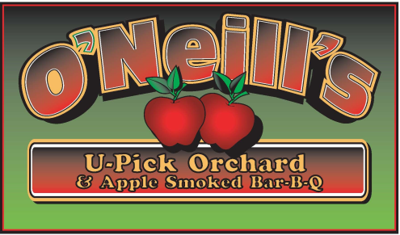

www.oneillsorchard.com
www.oneillsorchard.com

Open Mon – Sun 10am to 6pm
(315) 677-9407

Compliments of the season!

Our growing season started off early. However, the very long cool, wet April actually slowed their development to where ripening is about a week later than 2018. If the Paula Reds are ripe, we plan on opening on Saturday, August 24th. If not, we will open the following week.

Call to verify opening, availability and ripening or, like us on

Kitchen is open Saturdays and Sundays as well as on Labor Day and Columbus Day for: APPLE FRITTERS, APPLE CIDER DONUTS, BBQ, CIDER HOUSE FREEZE, HOT DOGS, CIDERS, WATER AND SODA.

Please remember to check for availability.

U-Pick | Apples | Estimated Ripening Date
Raspberries * | Zestar, Paula Red | August 24th??????????
Raspberries * | Ginger Gold, Jonamac | Early September
Raspberries * | McIntosh | Early to mid September
Raspberries * | Gala, Crimson Crisp | Mid September
Raspberries * | Honeycrisp | Mid September
Raspberries * | Cortland, McCoun, Greening | Mid to late September
Raspberries * | Empire, Jonagold | Early October
? | Golden Delicious, Red Delicious, N. Spy | Early to mid October
??? | Crispin, Ida Red | Late October
??????? | U-Pick?  Apples in stand | Early November

Keith F. O’Neill

4872 Route 20, Lafayette, New York 13084 (Just 4 min West from 81 Exit 15)
(315) 677-9407

20 APPLE VARIETIES*FALL RED RASPBERRIES *BREADS* FRITTERS*CIDER*PIES*PUMPKINS*CHEESE*BBQ

Like Us @ www.oneillsorchard
APPLE SMOKED BBQ
WEEKENDS ONLY

