2018
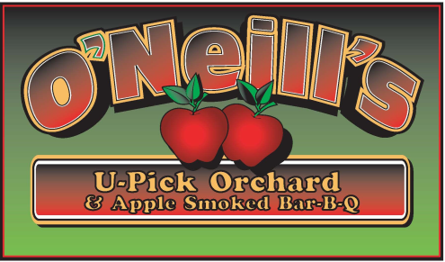

Open Mon – Sun 10am to 6pm
(315) 677-9407

Compliments of the season!

After a 3 week later bud break, the consistent heat that followed accelerated the growing season to a harvest that is about 5 days later than 2017s. If the Paula Reds are ripe, we plan on opening on Saturday, August 25th.

Weekends only BBQ will start on September 1st, 2nd and 3rd this year.

Call to verify opening, availability and ripening or, like us on

Kitchen is open Saturdays and Sundays as well as on Labor Day and Columbus Day for: APPLE FRITTERS, APPLE CIDER DONUTS, BBQ, CIDER HOUSE FREEZE, HOT DOGS, CIDERS, WATER AND SODA.

Please remember to check for availability.

U-Pick | Apples | Estimated Ripening Date
Raspberries * | Zestar, Paula Red | August 25th??????????
Raspberries * | Ginger Gold, Jonamac | Early September
Raspberries * | McIntosh | Early to mid September
Raspberries * | Gala, Crimson Crisp | Mid September
Raspberries * | Honeycrisp | Mid September
Raspberries * | Cortland, McCoun, Greening | Mid to late September
Raspberries * | Empire, Jonagold | Early October
? | Golden Delicious, Red Delicious, N. Spy | Early to mid October
??? | Crispin, Ida Red | Late October
One patch is being replanted. | U-Pick?  Apples in stand | Early to mid November

Keith F. O’Neill

4872 Route 20, Lafayette, New York 13084 (Just 4 min West from 81 Exit 15)
(315) 677-9407

18 APPLE VARIETIES*FALL RED RASPBERRIES *BREADS* FRITTERS*CIDER*PIES*PUMPKINS*CHEESE*BBQ

APPLE SMOKED BBQ
WEEKENDS ONLY
www.oneillsorchardbbq.com

