2017
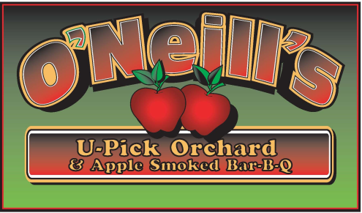

Open Mon – Sun 10am to 6pm
(315) 677-9407

Compliments of the season!

We have U-Pick apples this year! What a difference a year makes. Last year we had no apples or rain. This year we have apples and too much rain. We plan on opening on Saturday, August 26th.

Call to verify opening, availability and ripening.

Or, if you would like to know exactly when and what is available, Like us on Facebook.

Kitchen is open Saturdays and Sundays as well as on Labor Day and Columbus Day for: APPLE FRITTERS, APPLE CIDER DONUTS, BBQ, CIDER HOUSE FREEZE, HOT DOGS, CIDERS, WATER AND SODA.

Please remember to check for availability.

U-Pick | Apples | Estimated Ripening Date
Raspberries | Zestar, Paula Red | August 26th
Raspberries | Ginger Gold, Jonamac | Early September
Raspberries | McIntosh | Early to mid September
Raspberries | Gala, Crimson Crisp | Mid September
Raspberries | Honeycrisp | Mid September
Raspberries | Cortland, McCoun, Greening | Mid to late September
Raspberries | Empire, Jonagold | Early October
? | Golden Delicious, Red Delicious, N. Spy | Early to mid October
??? | Crispin, Ida Red | Late October
 | U-Pick?  Apples in stand | Early to mid November

Keith F. O’Neill

4872 Route 20, Lafayette, New York 13084 (Just 4 min West from Exit 15)
(315) 677-9407

18 APPLE VARIETIES*FALL RED RASPBERRIES *BREADS* FRITTERS*CIDER*PIES*PUMPKINS*CHEESE*BBQ

APPLE SMOKED BBQ
WEEKENDS ONLY
www.oneillsorchardbbq.com

